Over the past decade, the Information Technology (IT) industry has become one of the fastest growing industries in India because of which it has caught world attention. Indian IT-ITES industry grew at a rate of 33 % in FY2008. India is now being identified as powerhouse for incremental development of computer software. It has grown from USD 4 billion industry to USD 58.8 billion industry in FY2008-09 employing over 2 million people

**In 2020, the IT sector contributed 8% of India's GDP(GROSS DOMESTIC PRODUCT), and by 2025, it is anticipated to make up 10% of India's GDP**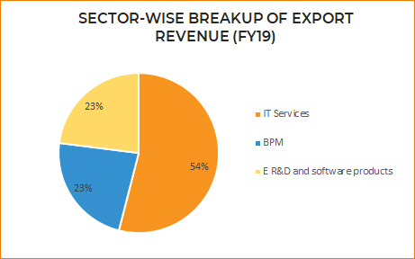

**Roll of IT-industry :-** IT is **the development, maintenance, and use of computer systems, software, and networks for the processing and distribution of data**. It is beneficial in making things simpler in the ever-evolving global manufacturing sector

**Future in IT-industry :- The continuing evolution of artificial intelligence will help businesses optimize their operations and take automation to new levels**. As edge computing becomes more intelligent, the world will benefit from smart roads, smart buildings, and real-time insights.